**Thread**

In computing, a **process** is an instance of a computer program that is being executed. Any process has 3 basic components:

* An executable program.
* The associated data needed by the program (variables, work space, buffers, etc.)
* The execution context of the program (State of process)

A **thread** is an entity within a process that can be scheduled for execution. Also, it is the smallest unit of processing that can be performed in an OS (Operating System).

In simple words, a **thread** is a sequence of such instructions within a program that can be executed independently of other code. For simplicity, you can assume that a thread is simply a subset of a process!

A thread contains all this information in a **Thread Control Block (TCB)**:

* **Thread Identifier:** Unique id (TID) is assigned to every new thread
* **Stack pointer:** Points to thread’s stack in the process. Stack contains the local variables under thread’s scope.
* **Program counter:** a register which stores the address of the instruction currently being executed by thread.
* **Thread state:** can be running, ready, waiting, start or done.
* **Thread’s register set:** registers assigned to thread for computations.
* **Parent process Pointer:** A pointer to the Process control block (PCB) of the process that the thread lives on.

Consider the diagram below to understand the relation between process and its thread:

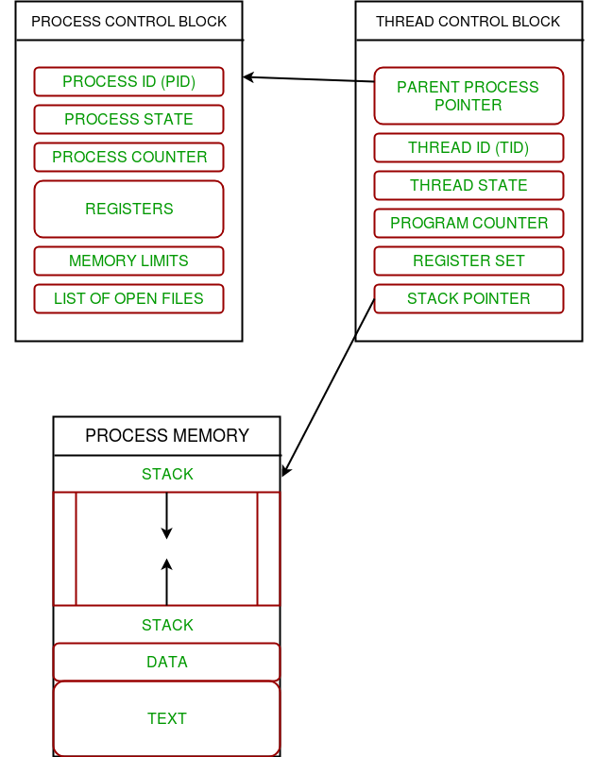

**Multithreading**

Multiple threads can exist within one process where:

* Each thread contains its own **register set** and **local variables (stored in stack)**.
* All thread of a process share **global variables (stored in heap)** and the **program code**.

Consider the diagram below to understand how multiple threads exist in memory:

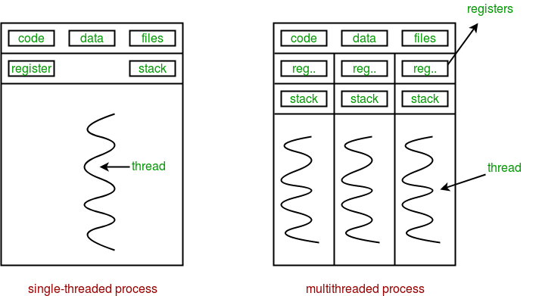

**Multithreading** is defined as the ability of a processor to execute multiple threads concurrently.

*In a simple, single-core CPU, it is achieved using frequent switching between threads. This is termed as****context switching****. In context switching, the state of a thread is saved and state of another thread is loaded whenever any interrupt (due to I/O or manually set) takes place. Context switching takes place so frequently that all the threads appear to be running parallelly (this is termed as****multitasking****).*

Consider the diagram below in which a process contains two active threads:

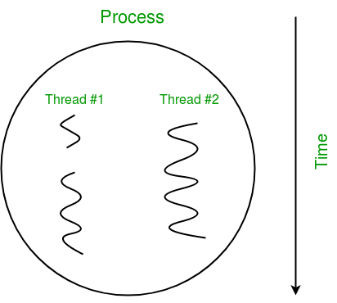

**Multithreading in Python**

In Python, the **threading** module provides a very simple and intuitive API for spawning multiple threads in a program.

Let us consider a simple example using threading module:

# Python program to illustrate the concept

# of threading

# importing the threading module

**import** threading

**def** print_cube(num):

    """

    function to print cube of given num

    """

    print("Cube: {}".format(num **\*** num **\*** num))

**def** print_square(num):

    """

    function to print square of given num

    """

    print("Square: {}".format(num **\*** num))

**if** __name__ **==** "__main__":

    # creating thread

    t1 **=** threading.Thread(target**=**print_square, args**=**(10,))

    t2 **=** threading.Thread(target**=**print_cube, args**=**(10,))

    # starting thread 1

    t1.start()

    # starting thread 2

    t2.start()

    # wait until thread 1 is completely executed

    t1.join()

    # wait until thread 2 is completely executed

    t2.join()

    # both threads completely executed

    print("Done!")

Output:

Square: 100

Cube: 1000

Done!

Let us try to understand the above code:

* To import the threading module, we do:

import threading

* To create a new thread, we create an object of **Thread** class. It takes following arguments:

**target**: the function to be executed by thread

**args**: the arguments to be passed to the target function

In above example, we created 2 threads with different target functions:

t1 = threading.Thread(target=print_square, args=(10,))

t2 = threading.Thread(target=print_cube, args=(10,))

* To start a thread, we use **start** method of **Thread** class.

t1.start()

t2.start()

* Once the threads start, the current program (you can think of it like a main thread) also keeps on executing. In order to stop execution of current program until a thread is complete, we use **join** method.

t1.join()

t2.join()

As a result, the current program will first wait for the completion of **t1** and then **t2**. Once, they are finished, the remaining statements of current program are executed.

Consider the diagram below for a better understanding of how above program works:

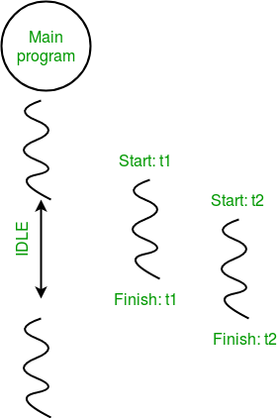

Consider the python program given below in which we print thread name and corresponding process for each task:

|  |
| --- |
| # Python program to illustrate the concept  # of threading  **import** threading  **import** os    **def** task1():  **print**("Task 1 assigned to thread: {}".format(threading.current_thread().name))  **print**("ID of process running task 1: {}".format(os.getpid()))    **def** task2():  **print**("Task 2 assigned to thread: {}".format(threading.current_thread().name))      print("ID of process running task 2: {}".format(os.getpid()))    **if** __name__ **==** "__main__":        # print ID of current process  **print**("ID of process running main program: {}".format(os.getpid()))        # print name of main thread  **print**("Main thread name: {}".format(threading.current_thread().name))        # creating threads      t1 **=** threading.Thread(target**=**task1, name**=**'t1')      t2 **=** threading.Thread(target**=**task2, name**=**'t2')        # starting threads      t1.start()      t2.start()        # wait until all threads finish      t1.join()      t2.join() |

Output:

ID of process running main program: 11758

Main thread name: MainThread

Task 1 assigned to thread: t1

ID of process running task 1: 11758

Task 2 assigned to thread: t2

ID of process running task 2: 11758

Let us try to understand the above code:

* We use **os.getpid()** function to get ID of current process.

print("ID of process running main program: {}".format(os.getpid()))

As it is clear from the output, the process ID remains same for all threads.

* We use **threading.main_thread()** function to get the main thread object. In normal conditions, the main thread is the thread from which the Python interpreter was started. **name** attribute of thread object is used to get the name of thread.

print("Main thread name: {}".format(threading.main_thread().name))

* We use the **threading.current_thread()** function to get the current thread object.

print("Task 1 assigned to thread: {}".format(threading.current_thread().name))

The diagram given below clears the above concept:

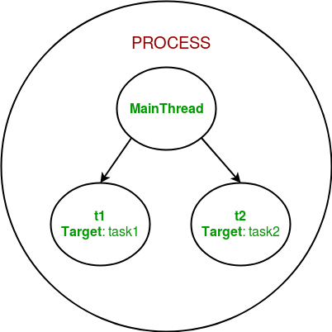

**Synchronization**

Thread synchronization is defined as a mechanism which ensures that two or more concurrent threads do not simultaneously execute some particular program segment known as **critical section**.

*Critical section refers to the parts of the program where the shared resource is accessed.*

For example, in the diagram below, 3 threads try to access shared resource or critical section at the same time.

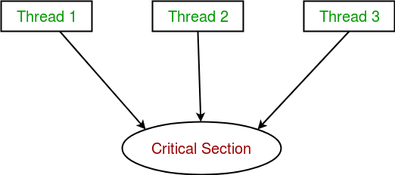

Concurrent accesses to shared resource can lead to **race condition**.

*A race condition occurs when two or more threads can access shared data and they try to change it at the same time. As a result, the values of variables may be unpredictable and vary depending on the timings of context switches of the processes.*

Consider the program below to understand the concept of race condition:

|  |
| --- |
| **import** threading    # global variable x  x **=** 0    **def** increment():      """      function to increment global variable x      """  **global** x      x **+=** 1    **def** thread_task():      """      task for thread      calls increment function 100000 times.      """  **for** _ **in** range(100000):          increment()    **def** main_task():  **global** x      # setting global variable x as 0      x **=** 0        # creating threads      t1 **=** threading.Thread(target**=**thread_task)      t2 **=** threading.Thread(target**=**thread_task)        # start threads      t1.start()      t2.start()        # wait until threads finish their job      t1.join()      t2.join()    **if** __name__ **==** "__main__":  **for** i **in** range(10):          main_task()  **print**("Iteration {0}: x = {1}".format(i,x)) |

Output:

Iteration 0: x = 175005

Iteration 1: x = 200000

Iteration 2: x = 200000

Iteration 3: x = 169432

Iteration 4: x = 153316

Iteration 5: x = 200000

Iteration 6: x = 167322

Iteration 7: x = 200000

Iteration 8: x = 169917

Iteration 9: x = 153589

In above program:

* Two threads **t1** and **t2** are created in **main_task** function and global variable **x** is set to 0.
* Each thread has a target function **thread_task** in which **increment** function is called 100000 times.
* **increment** function will increment the global variable **x** by 1 in each call.

The expected final value of **x** is 200000 but what we get in 10 iterations of **main_task** function is some different values.

This happens due to concurrent access of threads to the shared variable **x**. This unpredictability in value of **x** is nothing but **race condition**.

Given below is a diagram which shows how can **race condition** occur in above program:

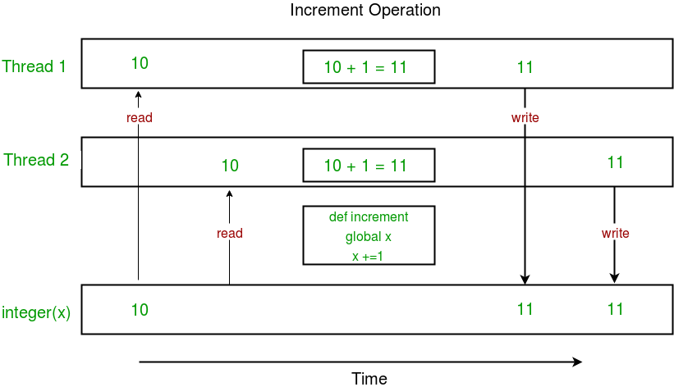

Notice that expected value of **x** in above diagram is 12 but due to race condition, it turns out to be 11!  
  
Hence, we need a tool for proper synchronization between multiple threads.

**Using Locks**

**threading** module provides a **Lock** class to deal with the race conditions. Lock is implemented using a **Semaphore** object provided by the Operating System.

*A semaphore is a synchronization object that controls access by multiple processes/threads to a common resource in a parallel programming environment. It is simply a value in a designated place in operating system (or kernel) storage that each process/thread can check and then change. Depending on the value that is found, the process/thread can use the resource or will find that it is already in use and must wait for some period before trying again. Semaphores can be binary (0 or 1) or can have additional values. Typically, a process/thread using semaphores checks the value and then, if it using the resource, changes the value to reflect this so that subsequent semaphore users will know to wait.*

**Lock** class provides following methods:

* **acquire([blocking]) :** To acquire a lock. A lock can be blocking or non-blocking.
  + When invoked with the blocking argument set to **True** (the default), thread execution is blocked until the lock is unlocked, then lock is set to locked and return **True**.
  + When invoked with the blocking argument set to **False**, thread execution is not blocked. If lock is unlocked, then set it to locked and return **True** else return **False** immediately.
* **release() :** To release a lock.
  + When the lock is locked, reset it to unlocked, and return. If any other threads are blocked waiting for the lock to become unlocked, allow exactly one of them to proceed.
  + If lock is already unlocked, a **ThreadError** is raised.

Consider the example given below:

|  |
| --- |
| **import** threading    # global variable x  x **=** 0    **def** increment():      """      function to increment global variable x      """  **global** x      x **+=** 1    **def** thread_task(lock):      """      task for thread      calls increment function 100000 times.      """  **for** _ **in** range(100000):          lock.acquire()          increment()          lock.release()    **def** main_task():  **global** x      # setting global variable x as 0      x **=** 0        # creating a lock      lock **=** threading.Lock()        # creating threads      t1 **=** threading.Thread(target**=**thread_task, args**=**(lock,))      t2 **=** threading.Thread(target**=**thread_task, args**=**(lock,))        # start threads      t1.start()      t2.start()        # wait until threads finish their job      t1.join()      t2.join()    **if** __name__ **==** "__main__":  **for** i **in** range(10):          main_task()          print("Iteration {0}: x = {1}".format(i,x)) |

Output:

Iteration 0: x = 200000

Iteration 1: x = 200000

Iteration 2: x = 200000

Iteration 3: x = 200000

Iteration 4: x = 200000

Iteration 5: x = 200000

Iteration 6: x = 200000

Iteration 7: x = 200000

Iteration 8: x = 200000

Iteration 9: x = 200000

Let us try to understand the above code step by step:

* Firstly, a **Lock** object is created using:

lock = threading.Lock()

* Then, **lock** is passed as target function argument:

t1 = threading.Thread(target=thread_task, args=(lock,))

t2 = threading.Thread(target=thread_task, args=(lock,))

* In the critical section of target function, we apply lock using **lock.acquire()** method. As soon as a lock is acquired, no other thread can access the critical section (here, **increment** function) until the lock is released using **lock.release()** method.

lock.acquire()

increment()

lock.release()

As you can see in the results, the final value of **x** comes out to be 200000 every time (which is the expected final result).

Here is a diagram given below which depicts the implementation of locks in above program:

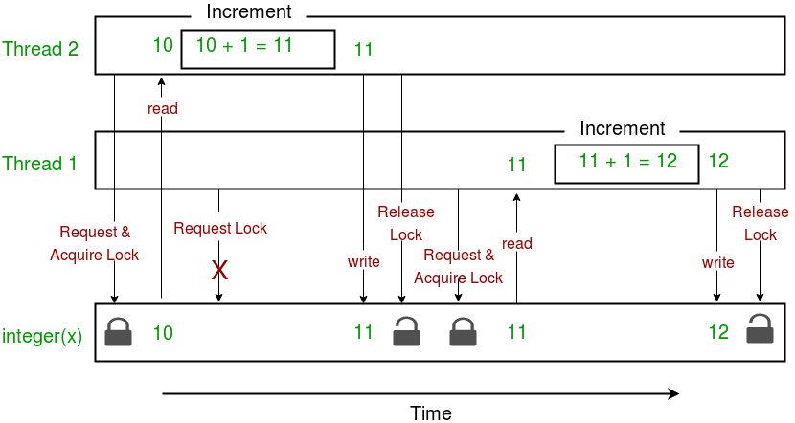

This brings us to the end of this tutorial series on **Multithreading in Python**.

Reference:

<https://www.geeksforgeeks.org/multithreading-python-set-1/?ref=lbp>

https://www.geeksforgeeks.org/multithreading-in-python-set-2-synchronization/